Part 1 New Method

The name of the method is concealLeftToRight(Picture underPic, double divisionWidth, double divisionHeight, int sourcePercent, int targetPercent). The transition animations in Windows Live Movie Maker inspire me to make a method that involved a transition. It works similarly to the reveal by looping through the rows and columns of a picture and instead of copying the pixels it blends the pixels of the original picture and a second picture.  The divisionWidth and divisionHeight parameters determine how much of each image is shown. A low percentage shows mostly the original, and a high percentage shows mostly the underPic. The sourcePercent and targetPercent determine the amount of color to blend from each picture. A low sourcePercent shows mostly the underPic, and a high sourcePercent shows mostly the original picture while a low targetPercent shows mostly the the original picture, and a high targetPercent shows mostly the underPic.

Part 2 Collage

I used pictures of my favorite movie, TV shows , and video games:

|  |  |  |
| --- | --- | --- |
|  | Name | Method Used |
| 1. | Mv1 | For(int I = 0; i < 100;i++)   pics.concealLeftToRight(worldPic, i/100.0, i/100.0, 5,95); |
| 2. | Tv1 | pic.blur(6); |
| 3. | Tv2 | pic.highlightLightAndDark(50.0, Color.yellow); |
| 4. | Tv4 | pic.horizontalShutters(5, Color.blue); |
| 5. | Tv5 | pic.blackOut(25,60,25,60); |
| 6 | Tv6 | pic.verticalShutters(5, Color.black); |
| 7. | Tv7 | pic.mirrorVertical(); |
| 8 | Vg1 | pic.fade();  (5 times) |
| 9. | Vg2 | pic.posterize(); |
| 10. | Vg3 | pic.negate(); |
| 11. | Vg4 | pic.colorfulEdgeDetection(7.0,50); |
| 12. | Vg5 | pic.quatrefoil(); |
| 13. | Vg6 | pic.blur(6); |
| 14. | Vg7 | pic.highlightLightAndDark(50.0, Color.yellow); |

The caption say’s Myron’s Favorites and the decorations I used are a red heart, a black music note, and a green dollar sign. I added the caption by using the TurtleAlphabet class. For the decorations I created methods inside of the turtle class to draw them. For the concealLeftToRight method I created another that it uses blend one pixel in two pictures. I also added parameter for size and color to the horizontalShutters and verticalShutters methods. For the movie class I added a method to the picture class that replaces a color with another color called replaceColor(Color oldColor, Color newColor, int thresold).

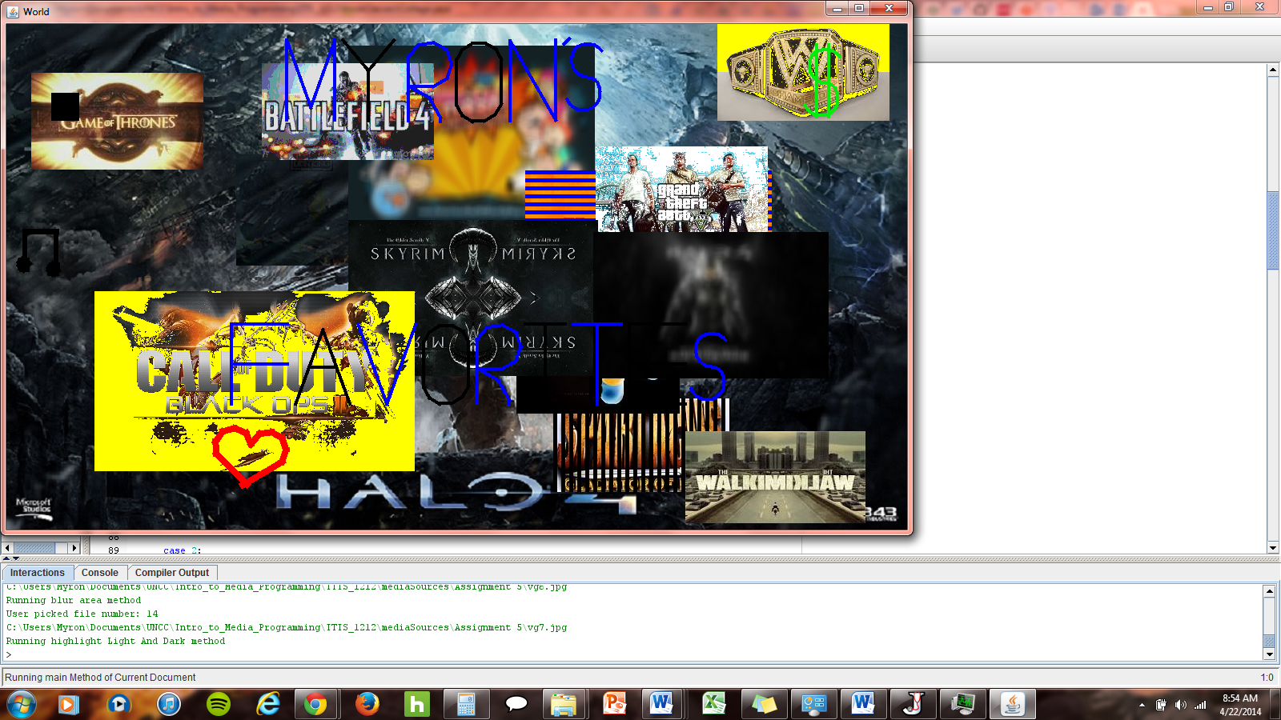––

Part 3 Movie

<https://www.youtube.com/watch?v=5lB-8wTeWI8>

Since I like Xbox I chose to make movie about the evolution of the Xbox gaming consoles.

|  |  |
| --- | --- |
| Pic | Methods |
| Xbox_console | mirrorVertical(); mirrorHorizontal();concealLeftToRight() |
| Xbox_360 | lighten2();horizontalShutters();verticalShutters(); reveal() |
| Xbox-one | replaceColor(); checkerboard(); |

Conclusion

The concealLeftToRight method I made works best with picture that are the same size but since the collage uses a bigger world picture I was unable to make it blend in as well unless I put the second picture in the top left corner of the world picture.

My favorite methods are the checkerboard methods and the reveal method because they were fun to figure out. My least favorite methods are the methods that involve drawing things with turtles because some of the drawings can involve a lot of trial and error.